**Error Handling**

**Scenario 1:**

CREATE OR REPLACE PROCEDURE SafeTransferFunds(

  from_id IN NUMBER,

  to_id   IN NUMBER,

  amt     IN NUMBER

) AS

  bal NUMBER;

BEGIN

  SELECT Balance INTO bal

  FROM Accounts

  WHERE AccountID = from_id FOR UPDATE;

  IF bal < amt THEN

    RAISE_APPLICATION_ERROR(-20001, 'Insufficient funds for transfer');

  END IF;

  UPDATE Accounts SET Balance = Balance - amt WHERE AccountID = from_id;

  UPDATE Accounts SET Balance = Balance + amt WHERE AccountID = to_id;

  DBMS_OUTPUT.PUT_LINE('Transfer successful.');

  COMMIT;

EXCEPTION

  WHEN OTHERS THEN

    DBMS_OUTPUT.PUT_LINE('Transfer failed: ' || SQLERRM);

    ROLLBACK;

END;

/

**Valid TestCase:**

BEGIN

  SafeTransferFunds(1,2, 500);

END;

/

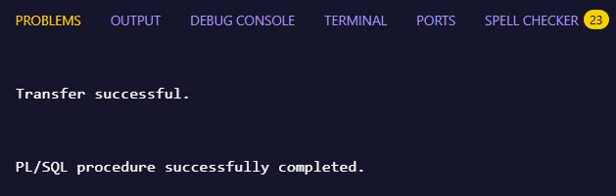**Output:**

**Invalid TestCase:**

BEGIN

  SafeTransferFunds(1, 2, 99999);

END;

/

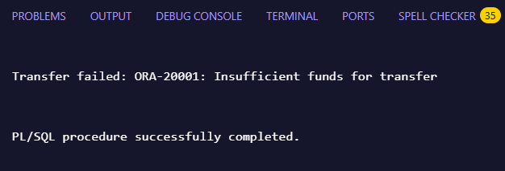**Output:**

**Scenario 2:**

CREATE OR REPLACE PROCEDURE UpdateSalary(

  emp_id IN NUMBER,

  pct    IN NUMBER

) AS

BEGIN

  UPDATE Employees

  SET Salary = Salary + (Salary * pct / 100)

  WHERE EmployeeID = emp_id;

  IF SQL%ROWCOUNT = 0 THEN

    RAISE_APPLICATION_ERROR(-20002, 'Employee ID not found.');

  END IF;

  DBMS_OUTPUT.PUT_LINE('Salary updated Successfully!');

  COMMIT;

EXCEPTION

  WHEN OTHERS THEN

    DBMS_OUTPUT.PUT_LINE('Error: ' || SQLERRM);

    ROLLBACK;

END;

/

BEGIN

  UpdateSalary(1, 10);

END;

/

**Valid TestCase:**

BEGIN

  UpdateSalary(999, 15);

END;

/

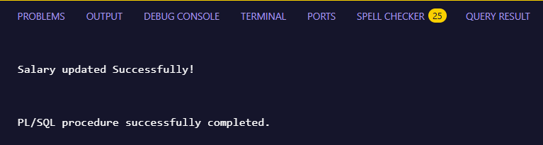**Output:**

**Invalid TestCase:**

BEGIN

  UpdateSalary(999, 15);

END;

/

**Output:**

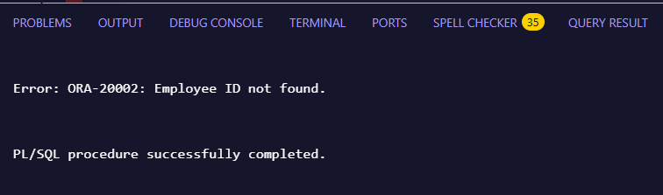

**Scenario 3:**

CREATE OR REPLACE PROCEDURE AddNewCustomer(

  cust_id IN NUMBER,

  cust_name IN VARCHAR2,

  dob IN DATE,

  bal IN NUMBER

) AS

BEGIN

  INSERT INTO Customers (CustomerID, Name, DOB, Balance, LastModified)

  VALUES (cust_id, cust_name, dob, bal, SYSDATE);

  DBMS_OUTPUT.PUT_LINE('New customer added Successfully!');

  COMMIT;

EXCEPTION

  WHEN DUP_VAL_ON_INDEX THEN

    DBMS_OUTPUT.PUT_LINE('Error: Customer ID ' || cust_id || ' already exists.');

  WHEN OTHERS THEN

    DBMS_OUTPUT.PUT_LINE('Error: ' || SQLERRM);

    ROLLBACK;

END;

/

**Valid TestCase:**

BEGIN

  AddNewCustomer(3, 'Elsa', TO_DATE('1999-04-15', 'YYYY-MM-DD'), 50000);

END;

/

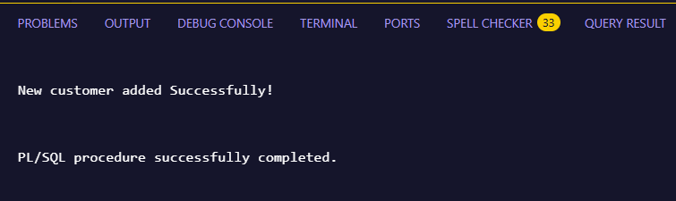**Output:**

**Invalid TestCase:**

BEGIN

  AddNewCustomer(3, 'Anna', TO_DATE('1988-03-15', 'YYYY-MM-DD'), 30000);

END;

/

**Output:**

